NAME : RAMISETTY SAMSHRITHA
CLUSTER 3 SECTION 7
sPractical-3:
Task-1:
Compilation and Execution:
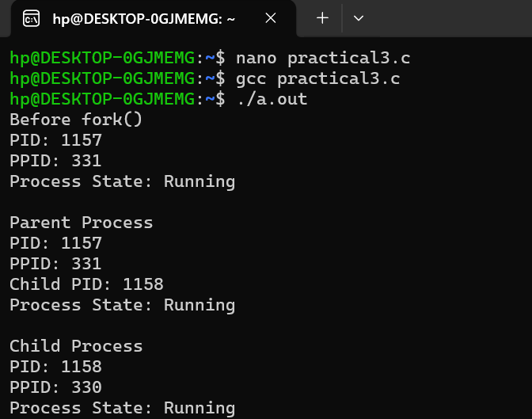

Task-2:
ps command:
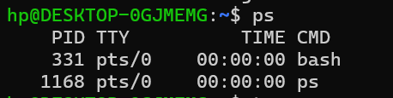

top command:

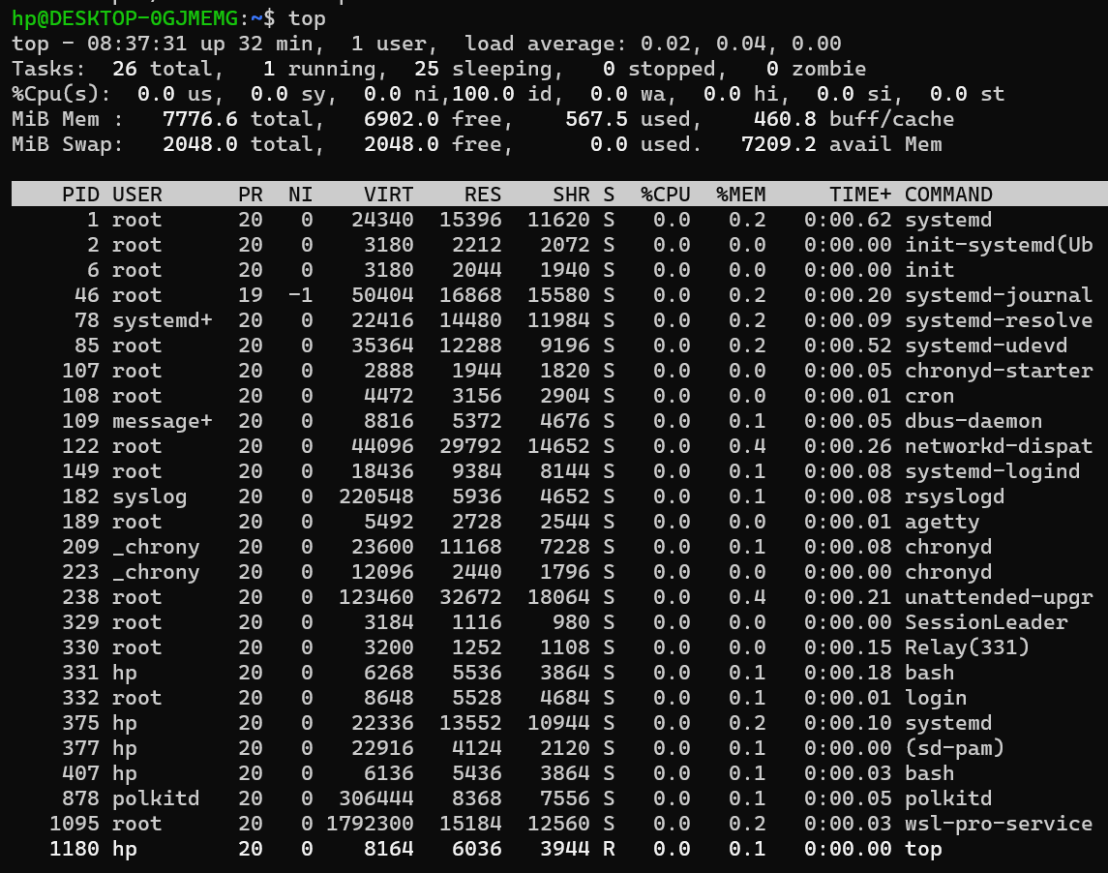

/proc:
